**DP LAB PROGRAMS**

**1.BINOMIAL COEFFICIENT**

def bin_coeff(n,k):

c=[[0]*(k+1) for _ in range (n+1)]

for i in range(n+1):

for j in range(min(i,k)+1):

if j==0 or j==i:

c[i][j]=1

else:

c[i][j]=c[i-1][j-1]+c[i-1][j]

return c[n][k]

n=5

k=2

print(bin_coeff(n,k))

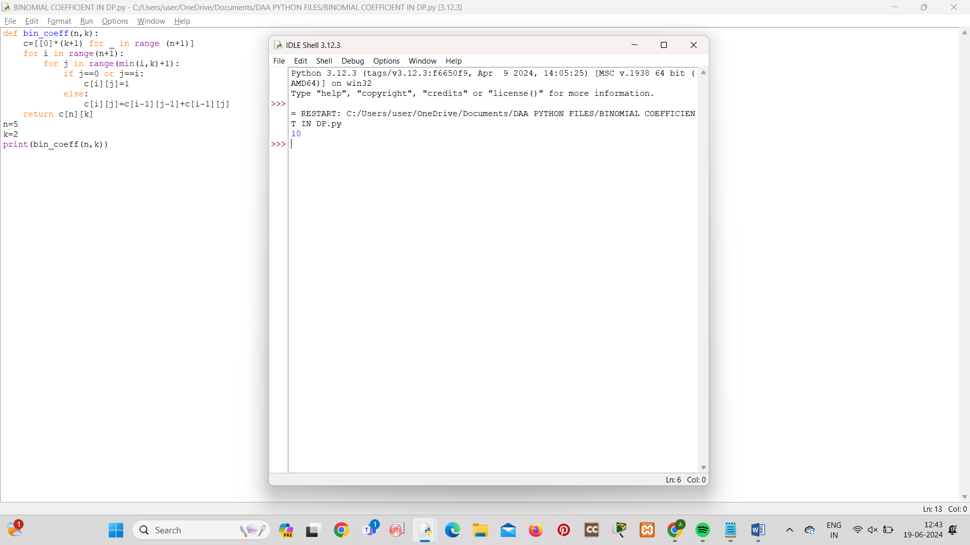

**2.WORD WRAP**

def word_wrap(text, width):

words = text.split()

lines = []

new_line = ""

for word in words:

if len(word) > width:

lines.append(new_line.strip())

lines.append(word)

new_line = ""

elif len(new_line + word) <= width:

new_line += word + " "

else:

lines.append(new_line.strip())

new_line = word + " "

if new_line:

lines.append(new_line.strip())

return "\n".join(lines)

text = "AN APPLE A DAY KEEPS THE DOCTOR AWAY"

print(word_wrap(text, 10))

